Integrated Annual Returns: https://labour.telangana.gov.in/
Procedure – Steps:
- If you don’t have an Entrepreneur Login Account - Please create a Login by providing mobile number with which you have previously done Shop & Establishment Registrations / Renewals – click on Login for Online Registration / License and Renewals.

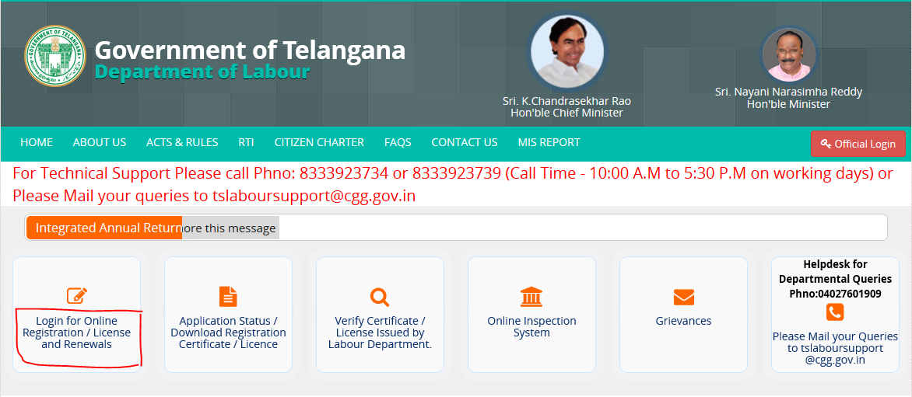

- Now Login into your account.
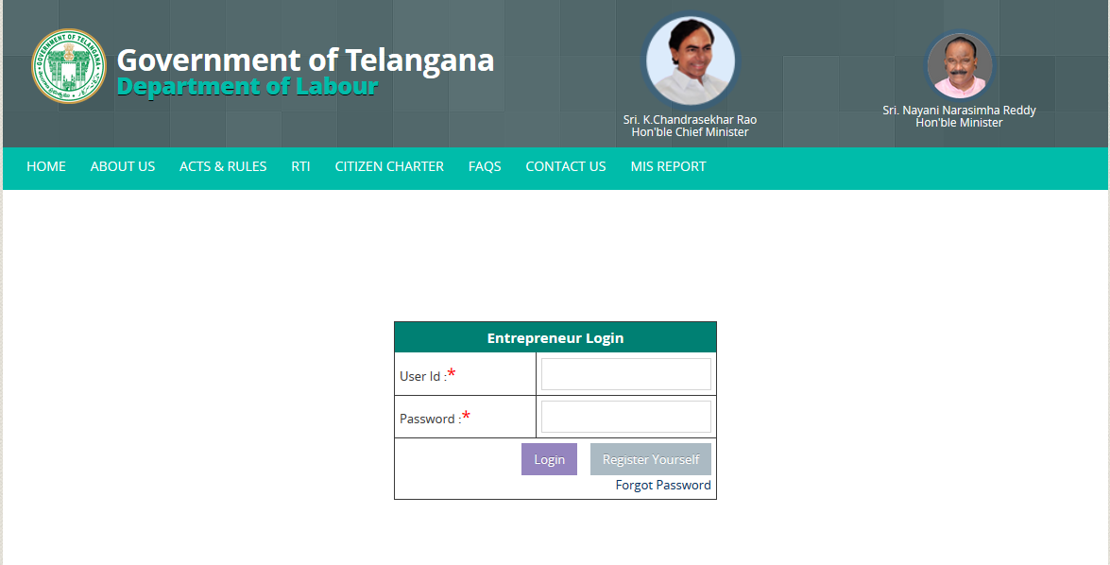

- After logging in, click on the REGISTRATIONS service available on the top menu.

- After Registrations page opens, at bottom of the screen under Schemes select Integrated Annual Return click on Register & File Return.
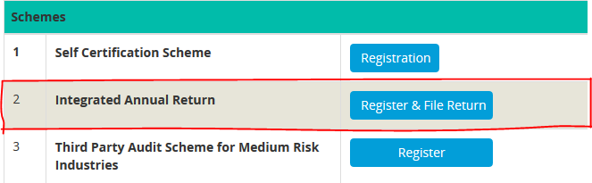

- Then in Approved Registrations page click on File Returns of the desired Application for which you want to submit / File the Returns and submit the details after filling the Application Form.
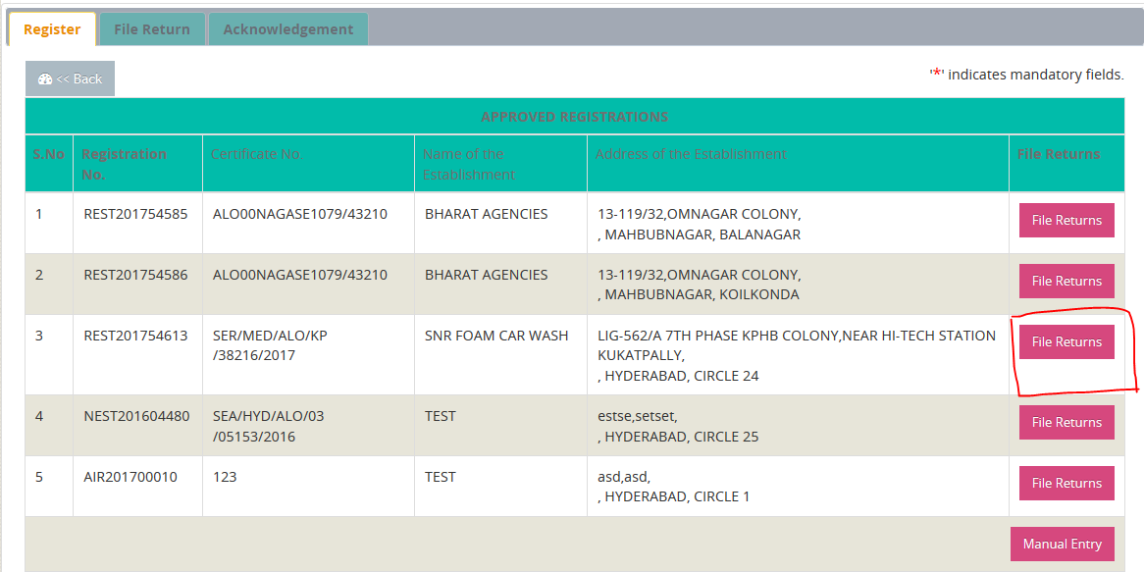

- If you have No Approved Applications available in the List, click on Manual Entry button and submit your details through Manual Entry application form.
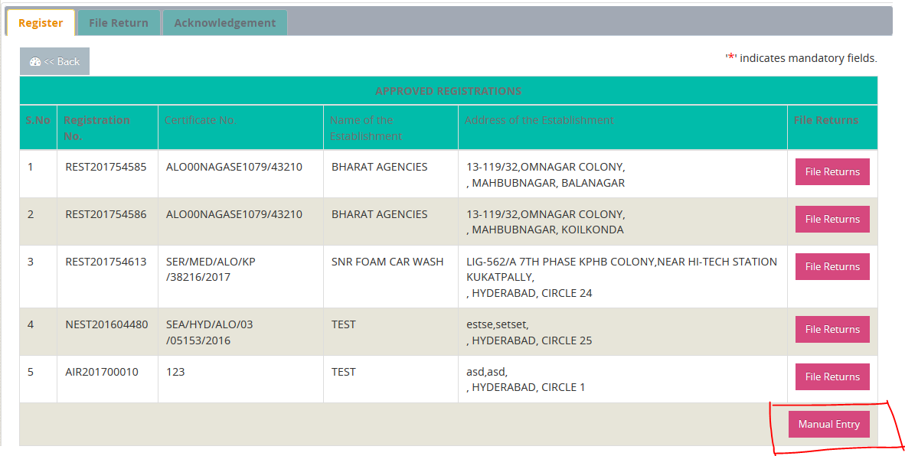

- If details are submitted through Manual Entry as mentioned in step 6, File Returns option for this application will be made available in the Approved Registrations List after Manual Entry Application form is submitted and now file the corresponding Returns by clicking on File Returns button as mentioned in step 5.
